Electrical Measurements
Unit I
1.Introduction :
In order to understand the concept of errors in measurement, we should know the two terms that defines the error and these two terms are written below:

1.1.1True Value
It is not possible to determine the true of quantity by experiment means. True value may be defined as the average value of an infinite number of measured values when average deviation due to various contributing factor will approach to zero.

1.1.2Measured Value
It may be defined as the approximated value of true value. It can be found out by taking means of several measured readings during an experiment, by applying suitable approximations on physical conditions.
Now we are in a position to define static error. Static error is defined as the difference of the measured value and the true value of the quantity.

1.1.3Limiting Errors or Guarantee Errors :
The concept of guarantee errors can better clear if we study this kind of error by considering one example. Suppose there is a manufacturer who manufactures an ammeter, now he should promises that the error in the ammeter is selling not greater the limit he sets. This limit of error is known as limiting errors or guarantee error.

1.1.4.Relative Error or Fractional Error
It is defined as the ratio of the error and the specified magnitude of the quantity

1.2.Types of Errors
Basically there are three types of errors on the basis; they may arise from the source.

1.2.1.Gross Errors
This category of errors includes all the human mistakes while reading, recording and the readings. Mistakes in calculating the errors also come under this category. For example while taking the reading from the meter of the instrument he may read 21 as 31. All these types of error are come under this category. Gross errors can be avoided by using two suitable measures and they are written below:
- A proper care should be taken in reading, recording the data. Also calculation of error should be done accurately.
- By increasing the number of experimenters we can reduce the gross errors. If each experimenter takes different reading at different points, then by taking average of more readings we can reduce the gross errors.

1.2.2.Systematic Errors
In order to understand these kinds of errors, let us categorize the systematic errors as

1.2.2.1.Instrumental Errors
These errors may be due to wrong construction, calibration of the measuring instruments. These types of error may be arises due to friction or may be due to hysteresis. These types of errors also include the loading effect and misuse of the instruments. Misuse of the instruments results in the failure to the adjust the zero of instruments. In order to minimize the gross errors in measurement various correction factors must be applied and in extreme condition instrument must be re-calibrated carefully.

1.2.2.2.Environmental Errors
This type of error arises due to conditions external to instrument. External condition includes temperature, pressure, humidity or it may include external magnetic field. Following are the steps that one must follow in order to minimize the environmental errors:
- Try to maintain the temperature and humidity of the laboratory constant by making some arrangements.
- Ensure that there should not be any external magnetic or electrostatic field around the instrument.

1.2.3Observational Errors
As the name suggests these types of errors are due wrong observations. The wrong observations may be due to PARALLAX. In order to minimize the PARALLAX error highly accurate meters are required, provided with mirrored scales.

1.2.4Random Errors
After calculating all systematic errors, it is found that there are still some errors in measurement are left. These errors are known as random errors. Some of the reasons of the appearance of these errors are known but still some reasons are unknown. Hence we cannot fully eliminate these kinds of error.

1.3.Classification of Secondary Instruments
(a) Classification based on the various effects of electric current (or voltage) upon which their operation depend. They are:
Magnetic effect: Used in ammeters, voltmeters, watt-meters, integrating meters etc.
Heating effect: Used in ammeters and voltmeters.
Chemical effect: Used in dc ampere hour meters.
Electrostatic effect: Used in voltmeters.
Electromagnetic induction effect: Used in ac ammeters, voltmeters, watt meters and integrating meters. Generally the magnetic effect and the electromagnetic induction effect are utilized for the construction of the commercial instruments. Some of the instruments are also named based on the above effect such as electrostatic voltmeter, induction instruments, etc.
(b) Classification based on the Nature of their Operations We has the following instruments.
1.3.1.Indicating instruments: Indicating instruments indicate, generally the quantity to be measured by means of a pointer which moves on a scale. Examples are ammeter, voltmeter, wattmeter etc. •
1.3.2Recording instruments: These instruments record continuously the variation of any electrical quantity with respect to time. In principle, these are indicating instruments but so arranged that a permanent continuous record of the indication is made on a chart or dial. The recording is generally made by a pen on a graph paper which is rotated on a dice or drum at a uniform speed. The amount of the quantity at any time (instant) may be read from the traced chart. Any variation in the quantity with time is recorded by these instruments. Any electrical quantity like current, voltage, power etc., (which may be measured lay the indicating instruments) may be arranged to be recorded by a suitable recording mechanism.
1.3.3Integrating instruments: These instruments record the consumption of the total quantity of electricity, energy etc., during a particular period of time. That is, these instruments totalize events over a specified period of time. No indication of the rate or variation or the amount at a particular instant are available from them. Some widely used integrating instruments are: Ampere-hour meter: kilowatthour (kWh) meter, kilovolt-ampere-hour (kVARh) meter.
1.4 FEATURES COMMON TO ALL INDICATING INSTRUMENTS
In this section we will discuss certain features which are common to all electrical measuring instruments. We will first consider various torques acting on its moving system. In an indicating instrument, it is essential that the moving system is acted upon by three distinct torque (or forces) for satisfactory working. There torques are:
1. A deflecting or operating torque, Td
2. A controlling torque, Tc
3. A damping torque, Tv.
1.4.1 Deflecting (Or the Operating) Torque
The deflecting torque, causes the moving system of the instrument to move from its zero position. It may be produced by utilizing any one of the effects of current or voltage in the instrument such as magnetic effect, electromagnetic induction effect, heating effect, electrostatic effect etc. The actual method of producing a deflecting torque depends upon the type of the instruments.
The deflecting torque has to supply the following torque-components presents in an instrument.
(a) The torque required to overcome the torque due to the inertia of the moving system.
(b) The torque required to overcome the controlling torque, Tc
(c) The torque required to overcome the damping torque, Tv
(d) The torque requirred to overcome the frictional (coulomb) torque.
1.4.2 Controlling Torque
The controlling torque developed in an instrument has two functions:
(a) It limits the movement of the moving system and ensures that the magnitude of the deflections always remains the same for a given value of the quantity to be measured.
(b) It brings back the moving system to its zero position where the quantity being measured is
removed or made zero. The controlling torque is dependent on the magnitude of deflection produced. The moving system is deflected from zero to such a position that the controlling torque at that deflected position is equal to the deflecting torque. The controlling torque increases in magnitude with the deflection till it balances the deflecting torque. That is, for a steady deflection,

Controlling torque, Tc = Deflection or operating torque, Td

Tc=Td

The controlling torque is entered in all commercial instruments by any one of the following
two ways.
• By means of one or two coiled springs. The corresponding insturment is termed spring
controlled instruments (mostly used system).
• By the action of gravity due to suitably placed weights on the moving system. Such instruments are known as gravity controlled instruments.
Spring control is now almost universal in indicating instruments. Gravity control is employed in a few cases, notably in special laboratory types. We will discuss the first two methods of
obtaining the controlling torque in a measuring instrument as given below.
1.4.2.1.Spring Control

Figure 12.1(a) shows a spindle free to turn between two pivots. The moving system is attached to the spindle. Two phosphor-bronze hair springs A and B wound in opposite directions are also shown whose inner ends are attached to the spindle. The outer end of spring A is connected to a leaver which is pivoted the adjustment of which gives zero setting. However, the outer end of B is fixed. When the pointer is deflected one spring unwinds itself while the other is twisted. This twist in the spring produces restoring (controlling) torque, which is proportional to the angle of deflection of the moving systems.
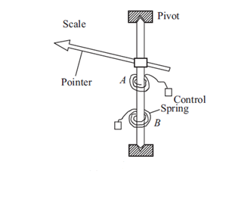

Fig.1.1pivoted moving system with spring control

Let E be the young-modulus for the material of the spring and θ (radians) be the deflection of the moving system to which one end of the spring is attached. Then, the controlling torque developed in the spiral spring is given by
where
l = Total length of spring strip (m)
b = depth of the strip (m)
t = thickness of the strip (m)
ks = spring constant
The spring material should also have the following properties:
* It should have low resistance
* The temperature coefficient should also be low.
• The springs must be of non-magnetic material.
In a permanent magnet moving coil type instrument the deflecting torque is proportional to the
current passing through them. Thus the operating torque, Td , is directly proportional to the
current,
Td = KI ...(12.14)
Then for spring control instrument, the controlling torque, TC, is
Tc = Ksθ...(12.15)
The pointer comes to rest when the deflecting torque (Td ) and the controlling or restoring
torque (Tc ) are equal, i.e., Td is equal and opposite to Tc.
At equilibrium, Td = Tc
Therefore, KI = Ksθ

I = (12.16)
This equation shows that the current is directly proportional to the deflection and since
Eqn. (12.16) is a linear relation, the scale with spring controlled instrument for deflecting
torque given by Eqn. (12.14) will be uniform throughout the scale.

1.4.2.2.Gravity Control
In gravity controlled instruments, as shown in Fig. 12.2 (a) a small adjustable weight is attached to the spindle of the moving system such that the deflecting torque produced by the instrument has to act against the action of gravity. Thus a controlling torque is obtained. This weight is called the control weight. Another adjustable weight is also attached is the moving system for zero adjustment and balancing purpose. This weight is called Balance weight.
When the control weight is in vertical position as shown in Fig. 12.2 (a), the controlling torque is zero and hence the pointer must read zero. However, if the deflecting torque lifts the controlling weight from position A to B as shown in Fig.12.2 (b) such that the spindle rotates by an angle θ, then due to gravity a restoring (or controlling) torque is exterted on the moving system.

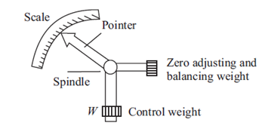
Fig.1.2.Gravity controlled moving system at zero deflection

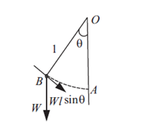
Fig.1.3.Moving system rotated by θ radian

The controlling (or restoring) torque, Tc, is given by
Tc = Wl sinθ = kg sinθ...(12.17)
where W is the control weight; l is the distance of the control weight from the axis of rotation of the moving system; and kg is the gravity constant.
Equation (12.18) shows the controlling torque can be varied quite simply by adjustment of the position of the control weight upon the arm which carries it.
Again, if the deflecting torque is directly proportional to the current, I i.e.,
Td = kI ...(12.18)
We have at the equilibrium position
Td = Tc
or kI = kg sinθ

I = sinθ
This relation shows that current I is proportional to sin θ and not θ. Hence in gravity controlled instruments the scale is not uniform. It is cramped for the lower readings, instead of being uniformly divided, for the deflecting torque assumed to be directly proportional to the quantity being measured.

Advantages of Gravity Control
1. It is cheap and not affected by temperature variations.
2. It does not deteriorate with time.
3. It is not subject to fatigue.

Disadvantages of Gravity Control
1. Since the controlling torque is proportional to the sine of the angle of deflection, the scale is
not uniformly divided but cramped at its lower end.
2. It is not suitable for use in portable instruments (in which spring control is always preferred).
3. Gravity control instruments must be used in vertical position so that the control weight may
operate and also must be leveled otherwise they will give zero error.
In view of these reasons, gravity control is not used for indicating instruments in general and
portable instruments in particular.

1.4.2.3.Difference between Gravity Control Spring Control
1. In gravity control, adjustable small weight is used which produces the controlling torque. In spring control, two hair springs are used which exert controlling torque.
2. Controlling torque can be varied in gravity control whereas controlling torque is fixed in spring.
3. In gravity, the performance is not temperature dependent while in the spring the performance is temperature dependent.
4. The scale is nonuniform in gravity. The scale is uniform in spring control.
5. The controlling torque is proportional to sin(angle) in the first whereas in the second, the controlling torque is proportional to the angle.
6. The readings can not be taken accurately in the gravity. The readings can be taken very accurately in the spring.
7. The system must be used in vertical position only in gravity control. The system need not be necessarily in vertical position in spring control.
8. Proper leveling is required as gravity control. The leveling is not required.

1.4.3Damping Torque
We have already seen that the moving system of the instrument will tend to move under the action of the
deflecting torque. But on account of the control torque, it will try to occupy a position of rest when the two torques are equal and opposite. However, due to inertia of the moving system, the pointer will not come to rest immediately but oscillate about its final deflected position
as shown in Fig. 12.3 and takes appreciable time to come to steady state. To overcome this difficulty a damping torque is to be developed by using a damping device attached to the moving system. The damping torque is proportional to the speed of rotation of the moving system, that is

Tv = kv
where kv = damping torque constant

= speed of rotation of the moving system

Depending upon the degree of damping introduced in the moving system, the instrument may have
any one of the following conditions as depicted in Fig.12.3.
1. Under damped condition: The response is oscillatory
2. Over damped condition: The response is sluggish and it rises very slowly from its zero
position to final position.
3. Critically damped condition: When the response settles quickly without any oscillation, the system is said to be critically damped. In practice, the best response is slightly obtained when the damping is below the critical value i.e., the instrument is slightly under damped.
The damping torque is produced by the following methods:

1.4.3.1.Air Friction Damping
In this type of damping a light vane or vanes having considerable area is attached to the moving system to develop a frictional force opposing the motion by reason of the air they displace. Two methods of damping by air friction are depicted in Fig.12.4.

Fig.1.4.Air friction damping
The arrangement of Fig.1.4 (b) consists of a light aluminium piston which is attached to the
moving system. This piston moves in a fixed chamber which is closed at one end. Either
circular or rectangular chamber may be used. The clearance (or gap) between the piston and
chamber walls should be uniform thorughout and as small as possible. When the piston
moves rapidly into the chamber the air in the closed space is compressed and the pressure of
air thus developed opposes the motion of the piston and thereby the whole moving system. If
the piston is moving out of the chamber, rapidly, the pressure in the closed space falls and the
pressure on the open side of the piston is greater than that on the opposite side. Motion is thus
again opposed. With this damping system care must be taken to ensure that the arm carrying
the piston should not touch the sides of the chamber during its movement. The friction which
otherwise would occur may introduce a serious error in the deflection.

The air friction damping is very simple and cheap. But care must be taken to ensure that the piston is not bent or twisted. This method is used in moving iron and hot wire instruments.

1.4.3.2.Fluid Friction Damping
• This form is damping is similar to air friction damping. The action is the same as in the air
friction damping. Mineral oil is used in place of air and as the viscosity of oil is greater, the
damping force is also much greater. The vane attached to the spindle is arranged to move in
the damping oil.
• It is rarely used in commercial type instruments.
• The oil used must fulfill the following requirements.
* It should not evaporate quickly
* It should not have any corrosive effect on metals.
* Its viscosity should not change appreciably with temperature.
* It should be good insulator.

Fig.1.5 Fluid friction damping
In Fig.1.5 a disc attached to the moving system is immersed in the fluid (damping
oil). When the moving system moves the disc moves in oil and a frictional drag is
produced. For minimizing the surface tension affect, the suspension stem of the disc
should be cylindrical and of small diameter.
Advantages of Fluid Friction Damping
1. The oil used for damping can also be used for insulation purpose in some forms of instruments which are submerged in oil.
2. The clearance between the vanes and oil chamber is not as critical as with the air friction
clamping system.
3. This method is suitable for use with instruments such as electrostatic type where the movement
is suspended rather than pivoted.
4. Due to the up thrust of oil, the loads on bearings or suspension system is reduced thereby the reducing the frictional errors.
Disadvantages of Fluid Friction Damping
1. The instruments with this type of damping must be kept always in a vertical position.
2. It is difficult to keep the instrument clean due to leakage of oil.
3. It is not suitable for portable instruments.
The fluid friction damping can be used for laboratory type electrostatic instruments.

1.4.3.3.Eddy Current Damping
Eddy current damping is the most efficient form of damping. The essential components in this type of damping are a permanent magnet; and a light conducting disc usually of aluminium. When a sheet of conducting material moves in a magnetic field so as to cut through lines of force, eddy currents are set up in it and a force exists between these currents and the magnetic field, which is always in the direction opposing the motion. This force is proportional to the magnitude of the current, and to the strength of field. The former is proportional to the velocity of movement of the conductor, and thus, if the magnetic field is constant, the damping force is proportional to the velocity of the moving system and is zero when there is no movement of the system. Figure 12.6 shows two methods of applying this method of damping. In Fig. 12.6(a) a thin disc of conducting, but non-magnetic material-usually copper of aluminium is mounted on the spindle which
carries the pointer of the instrument. When the spindle rotates, the edge of the disc cuts through the lines of force in the gap of a permanent magnet, and eddy currents, with consequent damping, are produced. An arrangement similar to this is often used in hotwire instruments.
Fig1.6.Eddy current damping
Fig 1.6 shows the essential parts of a permanent-magnet, moving coil, instrument. The
coil is wound on a light metal former in which eddy currents are induced when the coil moves in the permanent-magnet field. The directions of the eddy-current which in turn produce the damping torque due to the motion of the coil (clockwise) are as shown in Fig.12.6(b) and this will produce damping forces as indicated in the figure.

1.5. Permanent Magnet Moving Coil Instrument (Pmmc) :

The permanent magnet moving coil instrument is the most accurate type for D.C. Measurements. The working principle of these instruments is the same as that of the d’Arsonval type of galvanometers, the difference being that a direct reading instrument is provided with a pointer and a scale

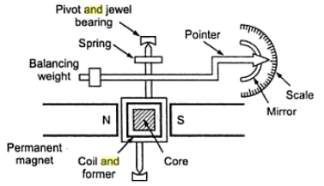

Fig.1.7. Construction of PMMC Instrument
1.5.1.Construction of PMMC Instruments
The constructional features of this instrument are shown in Fig. The moving coil is wound with many turns of enameled or silk covered copper wire. The coil is mounted on rectangular aluminum former, which is pivoted on jeweled bearings. The coils move freely in the field of a permanent magnet. Most voltmeter coils are wound on metal frames to provide the required electro-magnetic damping. Most ammeter coils, however, are wound on non-magnetic formers, because coil turns are effectively shorted by the ammeter shunt. The coil itself, therefore, provides electro magnetic damping. Magnet Systems Old style magnet system consisted of relatively long U shaped permanent magnets having soft iron pole pieces. Owing to development of materials like Alcomax and Alnico, which have a high co-ercive force, it is possible to use smaller magnet lengths and high field intensities. The flux densities used in PMIMC instruments vary from 0.1 Wb/m to 1 Wb/m.

1.5.2.Control
When the coil is supported between two jewel bearings two phosphor bronze hairsprings provide the control torque.
These springs also serve to lead current in and out of the coil. The control torque is provided by the ribbon suspension as shown.
This method is comparatively new and is claimed to be advantageous as it eliminates bearing friction.

1.5.3.Damping
Damping torque is produced by movement of the aluminum former moving in the magnetic field of the permanent magnet.

1.5.4.Pointer and Scale
The pointer is carried by the spindle and moves over a graduated scale. The pointer is of lightweight construction and, apart from those used in some inexpensive instruments has the section over the scale twisted to form a fine blade.
This helps to reduce parallax errors in the reading of the scale. When the coil is supported between two jewel bearings two phosphor bronze hairsprings provide the control torque. These springs also serve to lead current in and out of the coil.

1.5.5.Torque Equation for PMMC Instruments:
The deflecting torque equation for Permanent Magnet Moving Coil or PMMC Instruments is given as

Deflecting Torque Ƭ_{d} = NBLdI = GI

Where G = a constant = NBLd
Where N = Number of turns in the moving coil
B = magnetic flux density between the magnetic poles
L = Length of moving coil
d = Breadth of moving coil
As the controlling torque is provided by the spring, therefore

Ƭ_{c} = KƟ

Where K = Spring constant
Ɵ = Angular movement of coil
At steady state condition, deflecting and controlling torque shall be equal,
Ƭ_{d} = Ƭ_{c}
⇒ GI = KƟ

⇒ Ɵ = (G / K)I ……………………(1)

Thus from the above equation (1), we observe that deflection in Permanent Magnet Moving Coil or PMMC Instruments is directly proportional to the current flowing in the moving coil. Because of this the meter scale of such instrument for the measurement of current / voltage is linear.

1.5.6.Errors in Permanent Magnet Moving Coil Instruments
There are three main types of errors:
- Errors due to permanent magnets: Due to temperature effects and aging of the magnets the magnet may lose their magnetism to some extent. The magnets are generally aged by the heat and vibration treatment.
- Error may appear in PMMC Instrument due to the aging of the spring. However the error caused by the aging of the spring and the errors caused due to permanent magnet are opposite to each other, hence both the errors are compensated with each other.
- Change in the resistance of the moving coil with the temperature: Generally the temperature coefficients of the value of coefficient of copper wire in moving coil is 0.04 per degree celsius rise in temperature. Due to lower value of temperature coefficient the temperature rises at faster rate and hence the resistance increases. Due to this significant amount of error is caused.

Advantages of Permanent Magnet Moving Coil Instruments
- The scale is uniformly divided as the current is directly proportional to deflection of the pointer. Hence it is very easy to measure quantities from these instruments.
- Power consumption is also very low in these types of instruments.
- Higher value of torque is to weight ratio.
- These are having multiple advantages, a single instrument can be used for measuring various quantities by using different values of shunts and multipliers.
Instead of various advantages the permanent magnet moving coil instruments or PMMC Instrument posses few disadvantages.

Disadvantages of Permanent Magnet Moving Coil Instruments
- These instruments cannot measure ac quantities.
- Cost of these instruments is high as compared to moving iron instruments.

1.6.Moving Iron Instrument:
Moving Iron Instruments are the most common type of ammeter and voltmeter used at power frequencies in laboratories. These instruments are very accurate, cheap and rugged as compared to other AC instruments.

1.6.1.Working Principle of Moving Iron Instruments:(MI Attraction type instrument):
In Moving Iron Instruments, a plate or van of soft iron or of high permeability steel forms the moving element of the system. The iron van is so situated that it can move in the magnetic field produced by a stationary coil. Figure below shows a simple moving iron instrument.
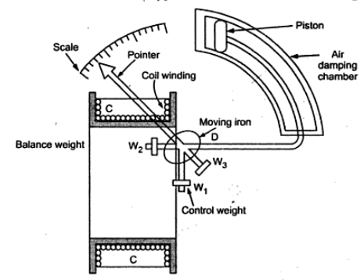

Fig.1.8.Moving Iron Attraction type instrument
The stationary coil is excited by the current or voltage under measurement. When the coil is excited, it becomes an electromagnet and the iron van moves in direction of offering low reluctance path. Thus the force of attraction is always produced in a direction to increase the inductance of coil. Mind that as the van follows the low reluctance path, the net flux in air gap will increase which means increased flux linkage of coil and hence inductance of coil will increase. It shall also be noticed that, the inductance of coil is variable and depends on the position of iron van.
1.6.2. Repulsion Type

One vane is rigidly attached to the coil frame while the other can rotate coaxially inside the stationary vane, as shown in Fig. 2.9. Both vanes are magnetized by the current in the coil to the same polarity, causing the vanes to slip laterally under repulsion. Because the moving vane is attached to a pivoted shaft, this repulsion results in a rotational force that is a function of the current in the coil. As in other mechanisms the final pointer position is a measure of the coil current. Since this movement, like all iron vane instruments, does not distinguish polarity, the concentric vane may be used on dc and ac, but it is most commonly used for the latter.

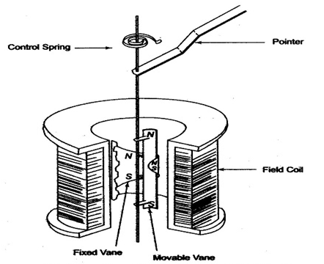

Fig.1.9.Moving iron repulsion type instrument

1.6.3.Torque Equation of Moving Iron Instruments
Suppose that, at any instant of time current flowing in the coil is I. Thus the energy stored in the coil in the form of magnetic field = (1/2)LI².
As soon as the current changes to (I+dI), deflection in the pointer becomes dƟ resulting into change in inductance of coil from L to (L+dL). Let this deflection in pointer is due to deflection torque Td.
Thus mechanical work done = Tdx dƟ ………………..(1)
Energy stored in Coil = (1/2)(L+dL)(I+dI)²
Change in stored energy of coil
= Final Stored Energy – Initial Stored Energy
= (1/2)(L+dL)(I+dI)² – (1/2)LI²
= (1/2)[ (L+dL)(I+dI)² – I²L]
= (1/2)[ (L+dL)(I²+2IdI+(dI)² – I²L]
= (1/2)[ LI²+2LIdI+L(dI)² + dLxI²+2IdIxdL+dLx(dI)² – I²L]
Neglecting second order and higher terms of differential quantities i.e. L(dI)², 2IdIxdL and dLx(dI)²

= (1/2)[ 2LIdI+dLxI²]
= LIdI +(1/2)dLx I² ……………………(2)
Again, just think, when there is a change of current from I to (I+dI), this change change of current must be accompanied by change in emf of coil. Thus we can write as
e = d(LI) / dt
= IdL/dt + LdI/dt
But electrical energy supplied by the source = eIdt
= (IdL + LdI) x I
= I²dL + LIdI
According to law of conservation of energy, this electrical energy supplied by the source is converted into stored energy in the coil and mechanical work done for deflection of needle of Moving Iron Instruments.
Hence,
I²dL + LIdI = Change in stored energy + Work done
⇒ I²dL + LIdI = LIdI +(1/2)dLx I² + Tdx dƟ ….[from (1) and (2)]
⇒ Tdx dƟ = (1/2)dLxI²
⇒ Td = (1/2)I²(dL/dƟ)
Thus deflecting torque in Moving iron Instruments is given as
Td = (1/2)I²(dL/dƟ)
From the above torque equation, we observe that the deflecting torque is dependent on the rate of change of inductance with the angular position of iron van and square of rms current flowing through the coil.
In moving iron instruments, the controlling torque is provided by spring. Controlling torque due to spring is given as
Tc = KƟ
Where K = Spring constant
Ɵ = Deflection in the needle
In equilibrium state, deflecting and controlling torque shall be equal as shown below.
Deflecting Torque = Controlling Torque
⇒ Td = Tc
⇒ (1/2)I²(dL/dƟ) = KƟ
⇒ Ɵ = (1/2)(I²/K)(dL/dƟ)
From the above torque equation, we observe that the angular deflection of needle of moving iron instruments is square of rms current flowing through the coil. Therefore, the deflection of moving iron instruments is independent of direction of current.

1.7.Basic D.C. Ammeter:

The basic d.c. ammeter is nothing but a D'Arsonval galvanometer. The coil winding of a basic movement is very small and light and hence it can carry very small current. For large currents, the major part of current is required to bypassed using a resistance called shunt. It is shown in the Fig. 1.

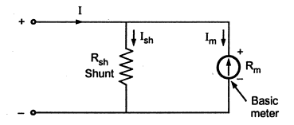

Fig.1.10.Basic D.C Ammeter
The shunt resistance can be calculated as :
Let R_{m} = Internal resistance of coil
R_{sh} = Shunt resistance
I_{m} = Full scale deflection current
I_{sh} = Shunt current
I = Total current
Now I = I_{sh} + I_{m}
As the two resistances R_{sh} and R_{m} are in parallel, the voltage drop across them is same.

1.8.Multirange Ammeter
The range of the basic d.c. ammeter can be extended by using number of shunts and a selector switch. Such ammeter is called multirange ammeter. and is shown in the Fig. 1.
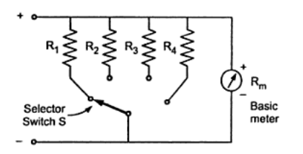
Fig.1.11.Multirange Ammeter
R₁ ,R₂ , R₃ and R₄ are four shunts. When connected in parallel with the meter, they can give four different ranges I₁ ,I₂ , I₃ and I₄. The selector switch S is multiposition switch, having low contact resistance and high current carrying capacity. The make before break type switch is used for the range changing.
If the ordinary switch is used, while range changing the switch remains open and full current passes through the meter. The meter may get damaged due to such high current. So make before break switch is used. The design of such switch is so that it makes contact with next terminal before completely breaking the contact with the previous terminal.
The multirange ammeters are used for the ranges upto 50 A. While using the multirange ammeter, highest range should be used first and the current range should be decreased till good upscale reading is obtained. All the shunts are very precise resistance and hence cost of such multirange ammeter is high.
The mathematical analysis of basic d.c. ammeter is equally applicable to such multirange ammeter. Thus,
R₁ = R_{m} /m₁ -1
R₁ = R_{m} /m₂ -1 and so on,
where m₁ ,m₂ ,m₃ .... are the shunt multiplying powers for the currents I₁ ,I₂ , I₃ ......

1.9.Basic D.C. Voltmeter:
The basic d.c. voltmeter is nothing but a PMMC D'Arsonoval galvanometer. The resistance is required to be connected in series with the basic meter to use it as a voltmeter.
This series resistance is called a multiplier. The main function of the multiplier is to limit the current through the basic meter so that the meter current does not exceed the full scale deflection value. The voltmeter measures the voltage across the two points of a circuit or a voltage across circuit component. The basic d.c. voltmeter is shown in the Fig. 1.

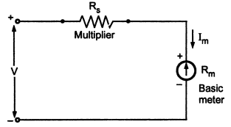
Fig.1.12.Basic D.C. Voltmeter
The voltmeter must be connected across the two points or a component, to measure the potential difference, with the proper polarity.
The multiplier resistance can be calculated as:
Let R_{m} = Internal resistance of coil i.e. meter
R_{s} = series multiplier resistance
I_{m} = full scale deflection current
V = full range voltage to be measured
From Fig 1, ... V = I_{m} (R_{m} + R_{s} )
... V = I_{m}R_{m} + I_{m} R_{s}
... I_{m}R_{s} = V - I_{m} R_{m}
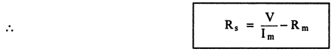

The multiplying factor for multiplier is the ratio of full range voltage to be measured and the drop across the basic meter.
Let v = drop across the basic meter = I_{m}R_{m}
m = multiplying factor = V/v
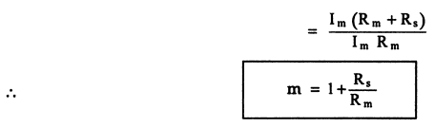

Hence multiplier resistance can also be expressed as,
R_{s} = (m-1)
Thus to increase the range of voltmeter 'm' times, the series resistance is (m-1) times the basic meter resistance. This is nothing but extension of ranges of a voltmeter.

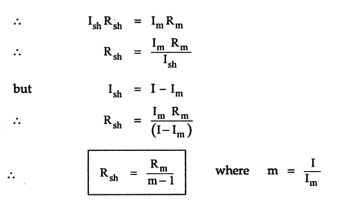

The m is called multiplying power of the shunt and defined as the ratio of total current to the current through the coil. It can be expressed as,
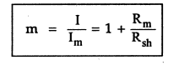

The shunt resistance may consist of a constant temperature resistance wire within the case of the meter or it may external shunt having low resistance.
Thus to increase the range of ammeter 'm' times, the shunt resistance required is 1/(m-1) time the basic meter resistance. This is nothing but extension of ranges of an ammeter.

1.10. Multirange Voltmeter:

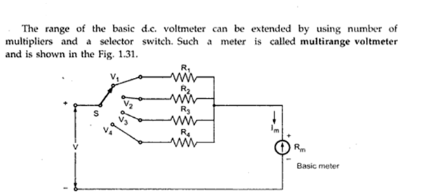
Fig.1.13.Multirange voltmeter

1.11.Ohmmeter:
The ohmmeter is a convenient direct reading device for measurement of resistance. These instruments have a low degree of accuracy. The statement regarding to the accuracy is not intended in an unfavorable sense. There is a wide field of application for this instrument in determining the approximate value of resistance. An ohmmeter is useful for determining the approximate resistance of circuit components such as heater elements or machine field coils, measuring and sorting of resistors used in electronic circuits, checking of semiconductor diodes and for checking of continuity of circuit.
It is also useful in laboratories as an aid to a precision bridge, for it can help to know the approximate value of resistance which can save time in balancing the bridge.
1.11.1.Series type ohmmeter:
A D’ Arsonval movement is connected in series with a resistance R₁ and a battery which is connected to a pair of terminals A and B, across which the unknown resistance is connected. This forms the basic type of series ohmmeter, as shown in Fig. 4.28 (a).
The current flowing through the movement then depends on the magnitude of the unknown resistance. Therefore, the meter deflection is directly proportional to the value of the unknown resistance.
R₁ = current limiting resistance
R₂ = zero adjust resistance
V = battery
R_{m} = meter resistance
R_{X} = unknown resistance
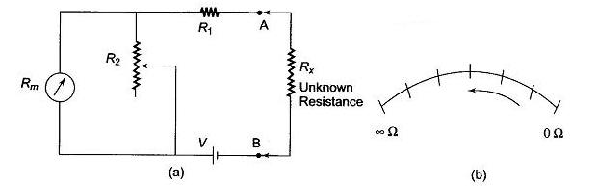

Fig.1.14.(a)Series type ohmmeter Fig.1.14.(b)Dial of series ohmmeter

1.11.2Calibration of the Series Type Ohmmeter
To mark the “0” reading on the scale, the terminals A and B are shorted, i.e. the unknown resistance R_{x}= 0, maximum current flows in the circuit and the shunt resistance R₂ is adjusted until the movement indicates full scale current (I_{fsd}). The position of the pointer on the scale is then marked “0” ohms.
Similarly, to mark the “∞” reading on the scale, terminals A and B are open, i.e. the unknown resistance R_{x} = ∞, no current flow in the circuit and there is no deflection of the pointer. The position of the pointer on the scale, is then marked as “∞” ohms.
By connecting different known values of the unknown resistance to terminals A and B, intermediate markings can be done on the scale. The accuracy of the instrument can be checked by measuring different values of standard resistance, i.e. the tolerance of the calibrated resistance, and noting the readings.
A major drawback in the series ohmmeter is the decrease in voltage of the internal battery with time and age. Due to this, the full scale deflection current drops and the meter does not read “0” when A and B are shorted. The variable shunt resistor R₂ across the movement is adjusted to counteract the drop in battery voltage, thereby bringing the pointer back to “0” ohms on the scale.
It is also possible to adjust the full scale deflection current without the shunt R₂ in the circuit, by varying the value of R₁ to compensate for the voltage drop. Since this affects the calibration of the scale, varying by R₂ is much better solution. The internal resistance of the coil R_{m} is very low compared to R₁. When R₂ is varied, the current through the movement is increased and the current through R₂ is reduced, thereby bringing the pointer to the full scale deflection position.
The series ohmmeter is a simple and popular design, and is used extensively for general service work.Therefore, in a series ohmmeter the scale marking on the dial, has “0” on the right side, corresponding to full scale deflection current, and “∞” on the left side corresponding to no current flow, as given in Fig. 4.28 (b).
Values of R₁ and R₂ can be determined from the value of R_{x} which gives half the full scale deflection.
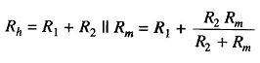
where
R_{h} = half of full scale deflection resistance.
The total resistance presented to the battery then equals 2R_{h} and the battery current needed to supply half scale deflection is I_{h}=V/2R_{h.}.
To produce full scale current, the battery current must be doubled.
Therefore, the total current of the ckt, I_{t}=V/R_{h}
The shunt current through R₂ is given by I₂=I_{t}-I_{fsd}
The voltage across shunt, V_{sh,} is equal to the voltage across the meter.
Therefore
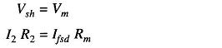
Therefore
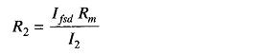
But
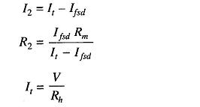
Therefore
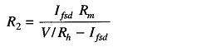
Therefore
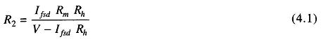
As
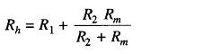
Therefore
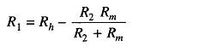
Hence
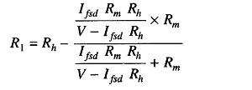
Therefore
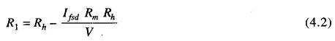
Hence, R₁ and R2 can be determined.
1.12.Shunt type ohmmeter:
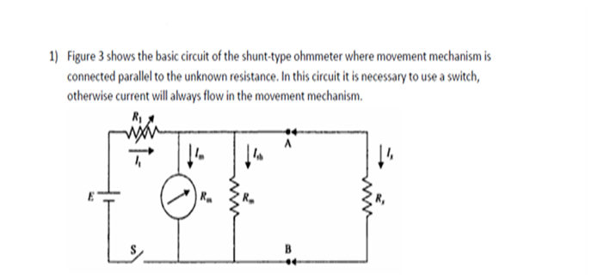

Fig.1.15.Shunt type ohmmeter

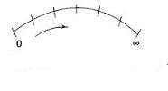
Fig.1.16.Dail of shunt type ohmmeter
1.13.Thermal Type Instruments:
There are mainly two types
1.Hot wire instrument
2.Thermal electric Instrument
1.13.1Hot Wire Instruments
The hot wire instruments are based on the principle that length of wire increases due to heating effect when a current passed through it. It is a square law device with a non-linear relationship because increase in length of a wire is directly proportional to the square of current passing through wire. Note that the increase in the length of a wire is very small percentage of the total length of wire. Hence various mechanical linkages have been devised to expand this effect and convert it into motion of a point of a circular scale.
1.13.2.Construction and operation:
The constructional details of a hot-wire double sag type instruments are as shown in the Fig. 1

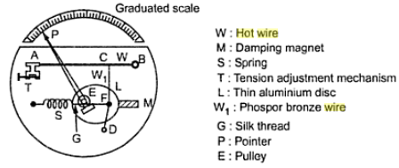
Fig.1.17.Hot wire instrument
A hot working wire denoted by W in the Fig.1 is made up of platinum-irridum alloy. The main advantages of using platinum-irridum alloy is that it can withstand high temperatures without deterioration of wire material caused by oxidation. The working wire W is very fine and its diameter is of the order of 0.1 mm. The wire W is stretched between two point A and B where point B is fixed point and point A is tension adjustment point at which tension adjustment mechanism is placed. One more wire W₁, made up of phosphor-bronze is connected to main hot wire W at point C while other end of wire W₁ is connected to fixed point D. A fine thread of silk material represented by G is connected between spring S and point F. The thread G is wound around a pulley denoted by E. Both points F and spring S are fixed points. A point P used for indication and thin aluminium disc L are mounted on the spindle. The pulley system E is also mounted on the spindle.
When a current to be measured is passed through the wire, it gets expanded as a result of heating effect by current flowing through it. Because of heating effect, a sag is produced in the wire W. Now the sag in main working wire W causes sag in other wire W₁. This sag is transferred to the spring S through a fine silk thread G. Thus the sag produced gets magnified and the spring activates pulley to rotate and pointer gets deflected indicating value of the current under measurement on a graduated scale.
The expansion of the wire is proportional to the heating effect of the current. As heat produced is in the form of power dissipated give P = I²R , the expansion of the wire in hot wire instrument is proportional to the square of r.m.s. value of the current. A thin aluminium disc L rotates between poles of the permanent magnet M and it provides eddy current damping to the instrument. The base of the main instrument is made up of a material which is having coefficient of expansion same as that of hot wire. As base and hot wire, both have same coefficient of expansion, the errors due to uneven expansion between base of instrument and hot wire are minimized.
In early hot wire instruments, the hot wire used was made up of platinum-silver alloy. But the main drawback of early instruments was the low value of the full-scale operating temperature ( about 135-150 ºC). Because of very low operating temperature, even small variations in room temperature affects the position of the pointer. Today's hot wire instruments use wire made up of platinum-irridum alloy with which operating temperature range can be extended upto 300 to 500 ºC. As the temperature range is increased, the effects due to room temperature variations are minimized. The hot wire is made very thin so that it can attain steady temperature quickly when current flows through wire. The size of wire is decided such that it can bare normal mechanical stresses developed in the instruments.
The hot wire instrument can be used as ammeter over a range 0 to 1 A without a shunt, while 0 to 5 A with a shunt. It can be used as a voltmeter to measure voltage upto 400 V by using high value non-inductive resistance in series with instruments.

1.13.3.Thermoelectric instrument:
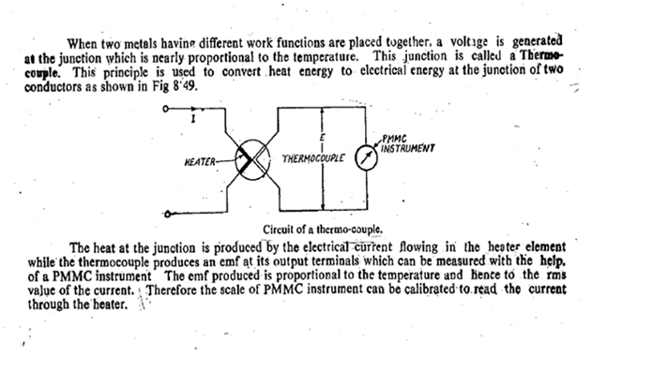
.

1.14.Electrostatic Instruments:
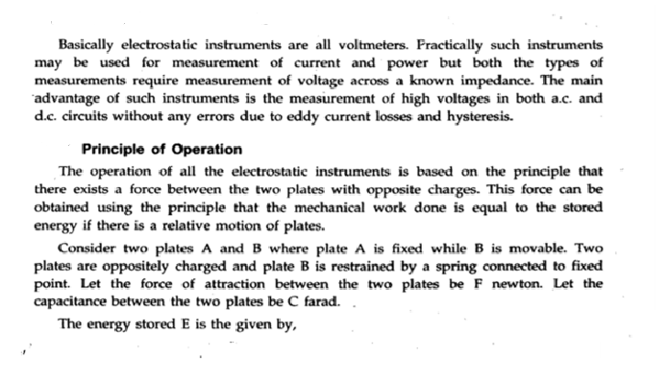
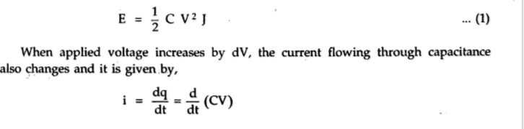

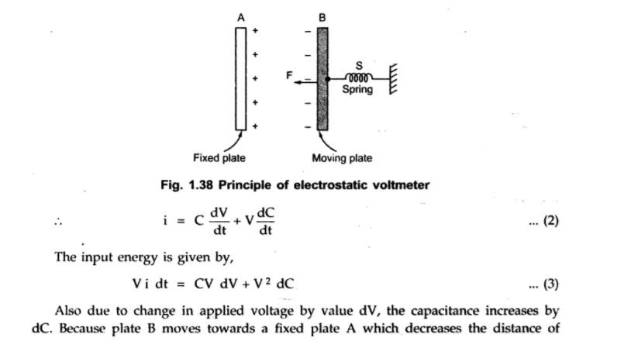
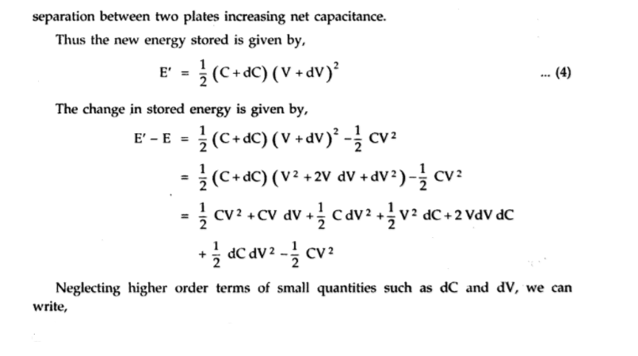
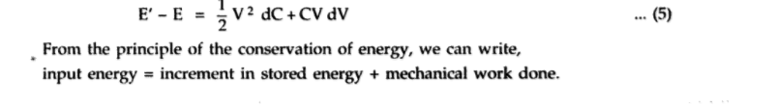
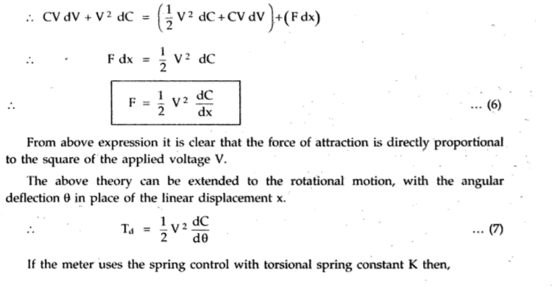
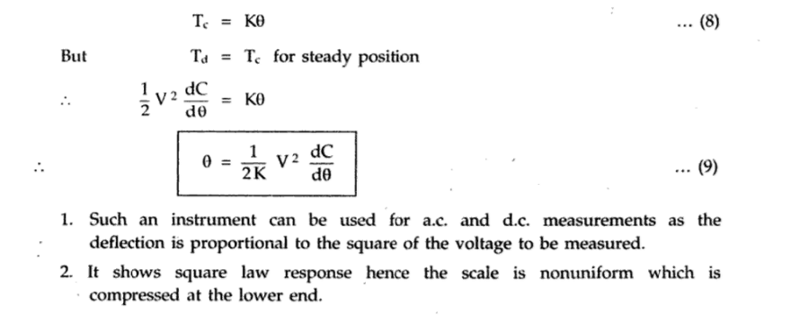
1.15.Types of Electrostatic Voltmeters:
